JAVA
PROJECT

CODE-

import java.util.*;

public class MunicipalWasteOptimizer {

static class Bin {
int id;
String location, type;
double fill, distance;

Bin(int id, String location, String type,
double fill, double distance) {
this.id = id;
this.location = location;
this.type = type;
this.fill = fill;
this.distance = distance;
}

// Calculate collection priority
double priority() {
int urgency;

if (type.equalsIgnoreCase("Organic"))
urgency = 30;
else if (type.equalsIgnoreCase("Recyclable"))
urgency = 20;
else
urgency = 10;

return fill + urgency - distance;
}

public String toString() {
return "Bin " + id +
" | " + location +
" | " + type +
" | Fill: " + fill + "%" +
" | Priority: " +
String.format("%.1f", priority());
}
}

// Display all bins
static void displayBins(ArrayList<Bin> bins) {
System.out.println("\n--- WASTE BIN DETAILS ---");

for (Bin b : bins)
System.out.println(b);
}

// Find the most urgent bin
static Bin highestPriority(ArrayList<Bin> bins) {

Bin best = bins.get(0);

for (Bin b : bins) {
if (b.priority() > best.priority())
best = b;
}

return best;
}

public static void main(String[] args) {

Scanner sc = new Scanner(System.in);

ArrayList<Bin> bins = new ArrayList<>();

// Sample municipal waste data
bins.add(new Bin(
101, "Kukatpally",
"Organic", 90, 5));

bins.add(new Bin(
102, "Miyapur",
"Recyclable", 70, 8));

bins.add(new Bin(
103, "Bachupally",
"General", 55, 12));

bins.add(new Bin(
104, "Moosapet",
"Organic", 85, 6));

int choice;

do {

System.out.println("\n================================");
System.out.println(" MUNICIPAL WASTE OPTIMISER");
System.out.println("================================");
System.out.println("1. Display all bins");
System.out.println("2. Find priority bin");
System.out.println("3. Add new bin");
System.out.println("4. Show critical bins");
System.out.println("5. Exit");
System.out.print("Enter choice: ");

choice = sc.nextInt();

switch (choice) {

case 1:
displayBins(bins);
break;

case 2:

Bin urgent = highestPriority(bins);

System.out.println(
"\nHighest Priority Bin:");
System.out.println(urgent);

break;

case 3:

System.out.print("Enter Bin ID: ");
int id = sc.nextInt();
sc.nextLine();

System.out.print("Enter Location: ");
String location = sc.nextLine();

System.out.print(
"Enter Waste Type: ");
String type = sc.nextLine();

System.out.print(
"Enter Fill Percentage: ");
double fill = sc.nextDouble();

System.out.print(
"Enter Distance from Depot: ");
double distance = sc.nextDouble();

if (fill >= 0 && fill <= 100) {

bins.add(new Bin(
id, location, type,
fill, distance));

System.out.println(
"Bin added successfully.");

} else {
System.out.println(
"Invalid fill percentage.");
}

break;

case 4:

System.out.println(
"\n--- CRITICAL BINS ---");

for (Bin b : bins) {

if (b.fill >= 80) {
System.out.println(
"URGENT -> " + b);
}
}

break;

case 5:

System.out.println(
"Thank you for using the system.");

break;

default:

System.out.println(
"Invalid choice.");
}

} while (choice != 5);

sc.close();
}
}

OUTPUT-
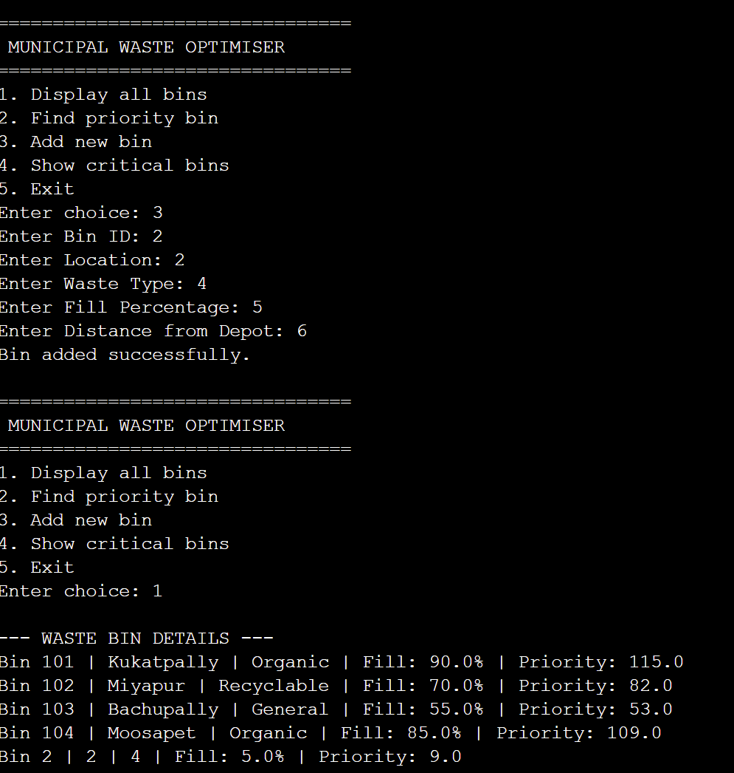
ABSTRACT-

The Municipal Waste Collection Optimiser is a Java-based application designed to improve the efficiency of municipal waste collection by prioritising waste bins based on their fill level, waste type, and distance from the collection depot. The system categorises waste into organic, recyclable, and general waste and assigns different urgency levels to each category. A priority score is then calculated to identify bins that require immediate collection, helping reduce unnecessary trips and improve resource utilisation.
The project is developed using core Java concepts such as classes and objects, methods, conditional statements, loops, arrays, ArrayList, exception handling, strings, and sorting techniques. A menu-driven interface allows users to view existing bins, add new bins, identify high-priority bins, and monitor critical waste levels. By combining computational thinking with object-oriented programming, the project demonstrates how a simple software solution can support smarter, more organised, and efficient municipal waste management.

Advantages of the Municipal Waste Collection Optimiser

- Efficient Waste Collection – Helps identify which waste bins need to be collected first based on their fill level and priority.
- Reduces Unnecessary Trips – Prioritising bins can help collection vehicles avoid visiting bins that do not require immediate collection.
- Saves Time and Fuel – Better planning of collection activities can reduce travel distance, time, and fuel consumption.
- Improves Waste Management – Helps municipal authorities monitor waste levels and organise collection more systematically.
- Prevents Overflowing Bins – Critical bins with high fill levels can be identified quickly, reducing the possibility of overflowing waste.
- Supports Different Waste Types – The system considers categories such as organic, recyclable, and general waste while calculating priority.
- Easy to Use – The menu-driven Java interface makes it simple to view bins, add new bins, and identify priority bins.
- Cost-Effective Solution – The project uses basic Java programming concepts and does not require expensive hardware or infrastructure.
- Scalable – More bins, locations, waste categories, and additional optimisation features can be added in the future.

CONCLUSION

The Municipal Waste Collection Optimiser provides a simple and effective approach to improving the organisation of municipal waste collection. By considering factors such as bin fill level, waste type, and distance from the collection depot, the system identifies bins that require higher priority for collection. This can help reduce unnecessary trips, prevent overflowing bins, and support better utilisation of collection resources.
The project also demonstrates the practical application of Java programming concepts such as classes and objects, methods, conditional statements, loops, ArrayList, strings, and menu-driven programming. Overall, the system provides a foundation for developing a more intelligent and technology-driven waste management solution.

FUTURE WORKS

The project can be further enhanced by integrating advanced technologies and real-time data. Possible future improvements include:
- IoT Sensors – Sensors can be installed in waste bins to automatically measure and transmit real-time fill levels.
- GPS Integration – GPS can be used to track collection vehicles and determine efficient routes.
- Route Optimisation – Algorithms can be added to generate the shortest or most efficient route for collecting high-priority bins.
- Mobile Application – A mobile app can allow municipal workers to view collection schedules, bin status, and assigned routes.
- Real-Time Notifications – The system can send alerts when a bin reaches a critical fill level.
- Database Integration – A database can store information about bins, collection history, vehicles, and locations.
- Predictive Analysis – Historical waste-generation data could be analysed to predict when bins are likely to become full.
- AI-Based Optimisation – Machine learning techniques could be introduced to improve priority calculation and collection planning based on historical patterns.

---THANK YOU---
K.Lakshmi Rupa Sree-2620030185
Viswanadhapalli Deva Tej-2620030187

